Balance the Register
- When is the register report completed?
- What 2 menu options from the POS screens will you select to
begin the process to balance the register?
- You work on Monday 3rd hour. You are using computer
number 1. What is your drawer description?
- You select the Current Drawer option. The Expected in Drawer
Field states it is $184.75. You count the quantity of the money in the till as follows. (Feel free to download a money counter to do this or figure it out with a calculator).

Total Expected in Drawer:
Quantity counted in each:
three - $20 bills,
one $10.00 bill,
eight $5.00,
fifty $1.00,
fifty-eight $.25 quarters
two $.10 dimes
one $.05 nickels

What is the total amount you counted?
Does the amount you counted equal the Expected in Drawer?
If no, what must you do first?
If you recount and still not equal, what should you do?
- You recount your till. The following is what you re-counted:

three - $20
two $10.00
eight $5.00,
fifty $1.00,
fifty-eight $.25 quarters
two $.10 dimes
one $.05 nickels

What is the total counted?

Does the amount you counted equal the Expected in Drawer?
It should be equal. If not, you did something incorrectly.
6. Now that it equals your expected in drawer for hour 3, complete the Cash Balance Posted Report for third hour on the next page.

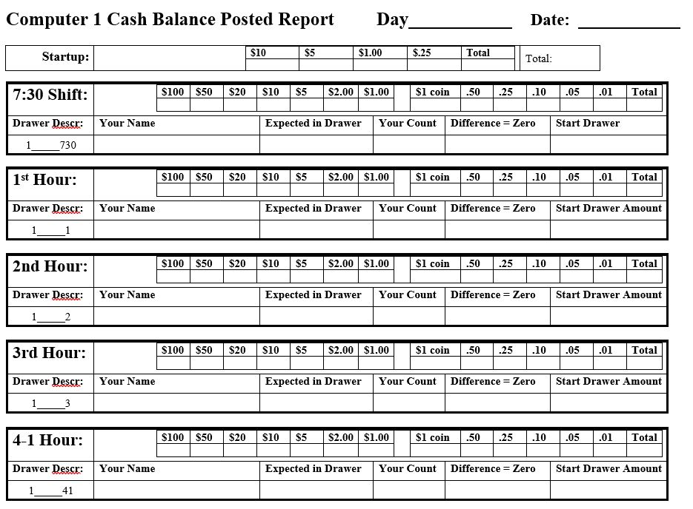
Day two, complete the fourth Hour balance register report. At the end of the hour you balance the register. When you select more, reports, the expected in drawer reads $252.25. You begin the balance register process by selecting “End Drawer” and count the money.

Your Count:
One $50
three - $20
three $10.00
eight $5.00
sixty one $1.00
One $1.00 coin
Forty $.25 quarters
two $.10 dimes
one $.05 nickels

- What is the Start Drawer Amount you will enter
to begin the next hour’s drawer with.

- If you do not complete the balance posted report
correctly, how many points are you deducted?

- If you do not balance the register at all, how
many points are deducted from your 20 points?
Remember, all shifts for the day will leave all the cash and checks in the POS except the last hour of the day, either 7th or 8th for make up shifts. The computer must be posted each hour and must equal a difference of zero.

